ACASA - Automated Compliance Auditing Software with AI
SPROJ Report



Shabbir 25100132
Ammad Akram 25100277
Saad Liaquat 25100259
Rida Amir 25100279

Advisor:
School of Science and Engineering
Lahore University of Management Sciences
19 May 2025

Acknowledgment and Dedication
We would like to extend our sincere gratitude to Dr. Waqar Ahmad and Dr. Sohaib Ayub for their continuous support, expert guidance, and valuable feedback throughout the design and development of ACASA. Their deep expertise in software engineering played a pivotal role in shaping the architectural design, implementation strategy, and overall technical direction of our project. From refining our development process to navigating complex system-level decisions, their mentorship was instrumental in bringing clarity and structure to our work.
We are equally thankful to Dr. Mobin Javed for her critical insights and strategic guidance during the early stages of the project. Her expertise in cybersecurity helped us gain a clear understanding of the use case, define the scope of our scripts, and identify the core security offerings we aimed to deliver through ACASA. Her input enabled us to set meaningful objectives and establish a focused direction for our cybersecurity components.
The collective mentorship, encouragement, and knowledge shared by these distinguished individuals have been vital to the success of our project, and we are deeply appreciative of their time and dedication.

Certificate
I certify that the senior project titled “ACASA” was completed under my supervision by the following students:

___________________________________________________________________
___________________________________________________________________
___________________________________________________________________

and the project deliverables meet the requirements of the program.

------------------------------------- Date:
Advisor (Signature)

------------------------------------- Date:
Co-advisor (if any)

Table of Contents
- Acknowledgment and Dedication
- Certificate
- Table of Contents
- List of Figures
- Introduction
- System Requirements
  - System Actors
  - Functional Requirements
  - Non-functional Requirements
- System Architecture
  - Architecture Diagram
  - Architecture Description
  - Justification of the Architecture
  - Tools and Technologies
- Requirements Specifications
  - Use Cases
  - Class Diagram
  - Sequence Diagrams
- Software Development Methodology and Plan
  - Software Process Selection
  - Gantt Chart
- Database Design and Web Services
  - Database Design
  - API Specification
- System User Interface
- Project Security
- Risk Management
- Testing and Evaluation
- Deployment Guidelines
- Conclusion
  - Summary
  - Challenges
  - Future Work
- Review Checklist
- References

List of Figures
- Figure 1: High Level Architecture Diagram
- Figure 2: Use Case Diagram
- Figure 3: Class Diagram
- Figure 4: Sequence Diagram UC-01
- Figure 5: Sequence Diagram UC-02
- Figure 6: Sequence Diagram UC-03
- Figure 7: Sequence Diagram UC-04
- Figure 8: Sequence Diagram UC-05
- Figure 9: Sequence Diagram UC-06
- Figure 10: Sequence Diagram UC-07
- Figure 11: Sequence Diagram UC-08
- Figure 12: Sequence Diagram UC-09
- Figure 13: Sequence Diagram UC-10
- Figure 14: Sequence Diagram UC-11
- Figure 15: Sequence Diagram UC-12
- Figure 16: Sequence Diagram UC-13
- Figure 17: Sequence Diagram UC-14
- Figure 18: Sequence Diagram UC-15
- Figure 19: Sequence Diagram UC-16
- Figure 20: Sequence Diagram UC-17
- Figure 21: Sequence Diagram UC-18
- Figure 22: Sequence Diagram UC-19
- Figure 23: Sequence Diagram UC-20
- Figure 24: Gantt Chart
- Figure 25: Database Design
- Figure 26: UI - 01 Splash Page
- Figure 27: UI - 02 Landing page
- Figure 28: UI - 03 Login page
- Figure 29: UI - 04 Dashboard page
- Figure 30: UI - 05 Controls page
- Figure 31: UI - 06 Controls page Upload Modal
- Figure 32: UI - 07 Controls page Automation Modal
- Figure 33: UI - 08 Controls page Import Modal
- Figure 34: UI - 09 Controls page Import Script Modal
- Figure 35: UI - 10 Policies page Select Policy Modal
- Figure 36: UI - 11 Policies page Create Policy Modal

Introduction

ACASA (Automated Compliance Auditing Software using AI) aims to automate and track the auditing process of compliance standards such as HIPAA, ISO 27001, PCI-DSS, GDPR and even custom compliance policies. It utilizes open-source libraries and AI-driven decision-making to address current market gaps, particularly by offering a cost-effective, fully automated solution.
Domain: The project falls under the domain of Compliance Automation / Information Technology.
Target Users:
- Compliance Officers
- IT Security Teams
- Executives
- Auditors
Product:
The product is a software system designed to automate compliance auditing. It involves a combination of:
- Web-based interface for users to interact with the system.
- Backend services to process data and execute audits.
- AI-driven modules for automated analysis of compliance.
- Scripts for automating security checks.

Objective and Scope
The main objective of ACASA is to track and automate the auditing process of compliance standards to reduce manual effort, improve accuracy, and increase efficiency. The system aims to provide a cost-effective solution that streamlines compliance processes for organizations. The system aims to be scalable and implementable across all compliance standards.
The scope of the project includes:
- Automating compliance checks for standards like HIPAA, ISO 27001, PCI-DSS, and GDPR.
- Developing AI modules to analyze compliance-related documents and configurations.
- Creating a user-friendly dashboard for compliance officers, IT security teams, executives, and auditors.
- Implementing features for document uploads, audit log reviews, and report generation.

Development Methodology
The development of ACASA follows the Agile-Scrum process. This methodology was chosen to allow for iterative development, flexibility in adapting to changing requirements, continuous stakeholder feedback, and better risk management. The project is divided into sprints, with each sprint focusing on delivering a working increment of the software.

Contributions
ACASA contributes to the field by:
- Automating compliance auditing significantly reduces the time and resources required for audits.
- Providing an AI-driven solution that enhances the accuracy and comprehensiveness of audits.
- Offering a cost-effective solution that makes compliance automation accessible to a wider range of organizations.
- Improving the audit process by providing real-time monitoring, detailed reporting, and proactive compliance management.

System Requirements
This chapter defines the key requirements for ACASA, covering both the actors who interact with the system and the specific capabilities it must provide. We detail functional requirements that drive the system’s core auditing features, followed by non‑functional requirements outlining performance, reliability, and security constraints. Together, these guidelines ensure a clear, shared vision of what ACASA must achieve and how it must behave under real‑world conditions.

System Actors
Actor Name | Description
Compliance Office | Responsible for ensuring that the organization adheres to relevant compliance standards.
IT Security Teams | Manage endpoint security and ensure systems remain compliant with industry regulations.
Executives | Require high-level reports on the organization’s compliance status for decision-making purposes.
Auditors | Conduct compliance audits either internally or externally, ensuring adherence to set standards.

Functional Requirements
[FR-1] As a compliance officer, I want to perform automated compliance audits to reduce manual effort.
[FR-2] As an IT security team member, I want to monitor endpoint security in real-time to ensure compliance with required standards (ISO 27001 Control 8.1 - User endpoint devices).
[FR-3] As an IT security team member, I want to ensure that access is restricted to privileged systems and actions (ISO 27001 Control 8.2 - Privileged access rights).
[FR-4] As an IT security team member, I want to ensure access to sensitive information is restricted based on user roles (ISO 27001 Control 8.3 - Information access restriction).
[FR-5] As an IT security team member, I want to monitor access to source code, so only authorized personnel can view and modify it (ISO 27001 Control 8.4 - Access to source code).
[FR-6] As an IT security team member, I want to monitor system capacity to ensure resources are sufficient and prevent system overload (ISO 27001 Control 8.6 - Capacity management).
[FR-7] As an IT security team member, I want to observe that the implemented network security protocols work properly to protect against unauthorized access (ISO 27001 Control 8.20 - Network security).
[FR-8] As an IT security team member, I want to ensure proper configurations are applied to network services to ensure secure access and communication (ISO 27001 Control 8.21 - Security of network services).
[FR-9] As an IT security team member, I want to monitor the segregation of networks to limit exposure in case of a breach (ISO 27001 Control 8.22 - Segregation of networks).
[FR-10] As an IT security team member, I want to observe applied web filtering controls to ensure that access to malicious or harmful websites is blocked (ISO 27001 Control 8.23 - Web filtering).
[FR-11] As an executive, I want to ensure that high-level compliance reports get an overview of the organization’s status.
[FR-12] As an auditor, I want to review compliance audit logs to verify the organization’s adherence to security regulations.
[FR-13] As a compliance officer, I want to ensure that information security policies are designed, stored in place, and regularly reviewed & updated (ISO 27001 Control 5.1 - Policies for information security).
[FR-14] As a compliance officer, I want to make certain that segregation of duties within the organization is applied to prevent conflicts of interest (ISO 27001 Control 5.3 - Segregation of duties).
[FR-15] As a compliance officer, I want to certify that labels on information are based on its sensitivity to ensure proper handling and protection (ISO 27001 Control 5.12 - Classification of information).
[FR-16] As a compliance officer, I want to certify that labels on information are based on its classification to aid in its protection (ISO 27001 Control 5.13 - Labeling of information).
[FR-17] As a compliance officer, I want to ensure that access control measures are enforced to verify that only authorized individuals can access sensitive information (ISO 27001 Control 5.15 - Access control).
[FR-18] As a compliance officer, I want to review access rights to ensure they are granted only as necessary (ISO 27001 Control 5.18 - Access rights).
[FR-19] As a compliance officer, I want to ensure the secure use of cloud services by implementing proper information security measures (ISO 27001 Control 5.23 - Information security for use of cloud services).
[FR-20] As an HR team member, I want to ensure employees sign confidentiality or non-disclosure agreements to protect sensitive information (ISO 27001 Control 6.6 - Confidentiality or non-disclosure agreements).
- [FR-21] As an HR team member, I want to ensure that employees’ terms and conditions of employment include provisions related to information security responsibilities (ISO 27001 Control 6.2 - Terms and conditions of employment).

Non-functional Requirements
[NF-1] The system should maintain memory usage below 2 GB during typical operations and should not exceed 3 GB during peak loads, ensuring efficient performance without crashing.
[NF-2] The system should restore normal operations within 5 minutes in the event of a failure.
[NF-3] The system must load the web dashboard and other critical functionalities like audit logs within 7 seconds to provide a seamless user experience.
[NF-4] The software should be capable of handling up to 10-15 concurrent users without a degradation in performance.
[NF-5] The system should maintain a 99.9% uptime excluding planned maintenance windows, ensuring high availability for users.
[NF-6] The system should be designed in a way that allows future extension with minimal impact on the core functionalities.

System Architecture
ACASA’s architecture is built as a stack of focused layers: an Electron Shell hosts the Next.js UI for all user interactions, fronted by a JWT-based Authentication layer. Core operations—document uploads, script management, control handling, report generation, and activity logging—live in the Business Logic layer (Next.js API routes). Heavy or untrusted computations run in an isolated Execution layer using temporary files and subprocesses. All entities and results are stored in individual MongoDB collections in the Database layer, while an on-prem SMTP infrastructure handles email notifications. This clear separation ensures modularity, security, performance, and easy future expansion.

Architecture Diagram

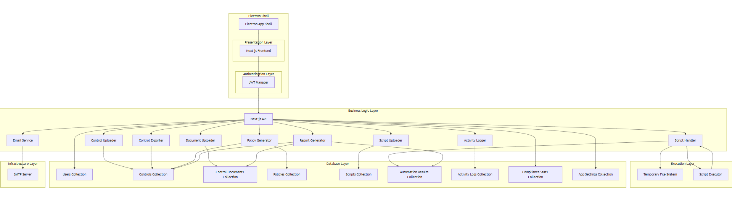

Architecture Description

The system is organized into six distinct layers—Electron Shell, Presentation, Authentication, Business Logic, Execution, Database, and Infrastructure—each responsible for a clear set of concerns and components.

Electron Shell
At the very top is the Electron Shell, which packages the Next.js application as a desktop executable. It provides a Chromium-based runtime and Node.js integration, allowing the web‐based UI to run natively on Windows, macOS, or Linux without a separate web server. Within this shell, the Next.js frontend is bootstrapped and rendered inside a desktop window
Presentation Layer
Within the Electron environment, the Presentation Layer consists solely of the Next.js Frontend. This component delivers a responsive, React-based user interface: pages for dashboards, forms, document upload, report viewing, policy editing, and configuration screens. All user interactions—clicks, form submissions, and navigation—originate here.

Authentication Layer
Directly adjacent to the presentation is the Authentication Layer, embodied by the JWT Manager. Upon user login or signup, the Next.js frontend hands credentials or email-verification tokens to the JWT Manager, which issues and validates JSON Web Tokens. These tokens are then attached to subsequent API calls to prove identity to maintain activity history and to grant access.

Business Logic Layer
The Business Logic Layer is hosted in Next.js API routes and orchestrates all core operations. It comprises nine specialized components:
- Document Uploader stores metadata and file references for evidence documents.
- Script Uploader accepts new automation scripts and persists their code and parameters.
- Control Uploader registers new compliance controls or updates existing ones.
- Control Exporter generates downloadable representations of control definitions.
- Policy Generator creates, versions, and publishes organizational policies linked to controls.
- Script Handler fetches script code, writes it to the execution workspace, and coordinates script runs.
- Report Generator aggregates control statuses, documents, and automation results into human-readable and machine-parseable audit reports.
- Activity Logger records every action (uploads, edits, exports, runs) to maintain an audit trail.
- Email Service dispatches organization-only signup verifications and system notifications via SMTP.
Each component exposes clean method-level APIs that the JWT-protected API layer invokes in response to frontend requests.

Execution Layer
Long-running or sensitive operations occur in the Execution Layer, isolated from the core API:
- Temporary File System provides an ephemeral workspace. When a script run is initiated, the Script Handler writes the fetched code to a temporary file here.
- Script Executor (a local Node.js or Python subprocess or Powershell subprocess) reads the temporary file, executes the compliance logic-accessing MongoDB or uploaded documents as needed—and streams its pass/fail output back to the Script Handler. Once complete, the executor signals the API layer, and the Temporary File System workspace is cleared.
This separation ensures that resource-intensive or untrusted script logic cannot destabilize the primary API process.

Database Layer
All persistent data resides in MongoDB, organized into individual collections for precise responsibility:
- Users Collection stores account credentials, roles, and status.
- Controls Collection holds ISO27001 control definitions and review metadata.
- Control Documents Collection tracks uploaded evidence files and their classifications.
- Policies Collection contains policy texts, versions, and related control links.
- Scripts Collection keeps automation code, input parameters, and metadata.
- Automation Results Collection logs each script run’s outcome and compliance verdict.
- Activity Logs Collection maintains a chronological audit trail of all user and system actions.
- Compliance Stats Collection aggregates real-time metrics and category breakdowns.
- App Settings Collection holds global configuration such as company details and allowed email domains.
This structure allows fine-grained queries, efficient indexing, and straightforward backups.

Infrastructure Layer
Finally, the Infrastructure Layer consists of the on-prem SMTP Server. The Email Service component communicates with this relay to send verification links, password resets, and alert notifications, ensuring that all email traffic remains within the organization’s controlled environment.
Together, these layers form a robust, modular, and secure on-prem desktop application: the Electron Shell provides the runtime, the Presentation and Authentication layers handle user interaction and security, the Business Logic and Execution layers perform domain-specific processing, MongoDB persists every artifact, and SMTP supports trusted communications.

Justification of the Architecture
Pros
- Clear Separation of Concerns
Each layer (Electron Shell, Presentation, Authentication, Business Logic, Execution, Database, Infrastructure) has a well-defined responsibility, making the system easier to understand, test, and maintain.
- Security by Isolation
Authentication is centralized in its own layer (JWT Manager), and untrusted or long-running scripts execute in a separate process with ephemeral filesystem access, reducing the blast radius of any failure or malicious code.
- On-Premise Control
All components—including the database, SMTP relay, and script execution—run entirely within your organization’s infrastructure, ensuring data never leaves your network and simplifying compliance with internal policies.
- Modularity and Extensibility
Adding new features (e.g. a new script type, a policy report, or additional controls) only requires plugging into the appropriate layer or adding a new component in the Business Logic layer.
Cons
- Resource Constraints
Running everything—Electron, Node.js API, MongoDB, script executors—on a single machine can strain CPU, memory, and I/O if usage grows beyond expected desktop-app load.
- Complexity of Packaging
Bundling Next.js, Node.js API routes, and a script-execution environment into an Electron shell requires careful build and update processes to keep all parts in sync.
- Limited Horizontal Scalability
Unlike a cloud-native microservices deployment, scaling out beyond one or two on-prem nodes involves more operational overhead (e.g. database clustering or multiple Electron installer versions).

NFR Alignment
- Security
  - Authentication & Authorization: Central JWT Manager ensures stateless, tamper-proof tokens.
  - On-Prem Data Residency: MongoDB, filesystem, and SMTP all reside within your firewall.
  - Execution Sandbox: Script Executor runs in a child process with only temporary-file access.
- Performance & Responsiveness
  - Server-Side Rendering: Next.js frontend delivers instant page loads and dynamic content.
  - Isolated Script Runs: Long-running automation tasks do not block the main API event loop.
- Maintainability & Modularity
  - Layered Architecture: Clear module boundaries simplify debugging, testing, and future enhancements.
  - Componentized Business Logic: Each service (e.g. Document Uploader, Report Generator) can be developed and deployed independently.
- Reliability & Availability
  - Process Isolation: Crashes in the Script Executor do not bring down the core API.
  - Audit Trail: Activity Logger and AutomationResults provide full traceability for troubleshooting.
- Extensibility & Future Growth
  - Plug-In-Style Scripts: New compliance checks or policy generators can be added simply by inserting new script records into MongoDB.
  - Configuration Store: App Settings and Compliance Stats collections allow runtime tuning without code changes.

Tools and Technologies
Next.js + MongoDB

This architecture balances the needs of a secure, on-prem desktop application with the flexibility to evolve and integrate new compliance workflows over time.

Requirements Specifications

Use Case Diagram
The use‐case diagram centers on a single User actor who can sign up (with organizational‐domain validation and email verification) or log in to gain access to a unified dashboard.
From there, the user manages controls (by exporting, importing, uploading evidence, manually toggling compliance, and attaching scripts), executes automation (running selected scripts against controls and viewing execution history), and handles policies (designing, saving, and downloading).
Throughout every action—whether document upload, control export, script execution, or policy download—an activity log entry is created, and compliance statistics are updated for display on the dashboard.
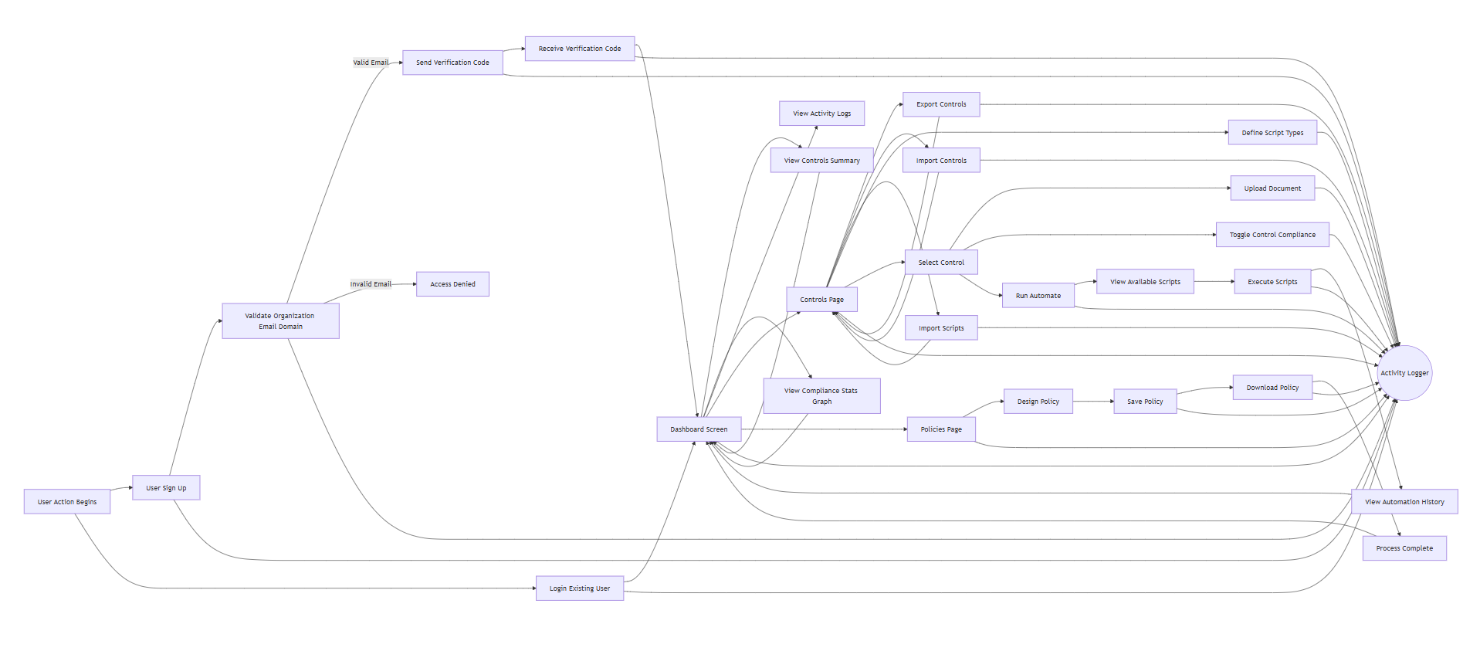

Use Cases

3.a.1 User Authentication
Identifier |  | UC-01
Purpose |  | Secure system access through verified user credentials.
Pre-conditions |  | User is at the login interface.
Post-conditions |  | User is authenticated and logged in.
Step # | Typical Course of Action
 | User logs in
2. | System authenticates.
3. | System grants access based on credentials.
Step # | Alternate Courses of Action
 | At Step 1 and Step 3 provide password reset or retrieval options if login fails.
Step # | Exception Paths
 | In Step 2, If the system cannot access the user database, display an error and log the incident.
3.a.2 User Registration / Sign Up
Identifier |  | UC-02
Purpose |  | Enable new users to create accounts to access system features.
Pre-conditions |  | New user has valid email and agrees to terms.
Post-conditions |  | User account is created and able to access the system.
Step # | Typical Course of Action
 | User provides details;
2. | System registers and confirms via email.
Step # | Alternate Courses of Action
1. | If email is already in use, suggest login instead.
Step # | Exception Paths
1. | If registration fails, provide an error message and log the incident.

3.a.3 Document Upload for Compliance Checking
Identifier |  | UC-03
Purpose |  | Allow users to upload documents necessary for compliance evaluation.
Pre-conditions |  | User is authenticated and on the upload interface.
Post-conditions |  | Documents are stored for analysis.
Step # | Typical Course of Action
 | User uploads files
2. | System validates and stores them securely.
Step # | Alternate Courses of Action
 | Notify user of unsupported file types or sizes and provide guidance.
Step # | Exception Paths
 | If upload fails due to server issues, log the event and alert the user to try later.

3.a.4 Checklist and Proof Storage for Manual Auditing
Identifier |  | UC-05
Purpose |  | Store checklists and proofs for manual auditing of compliance rules.
Pre-conditions |  | User has a checklist and proof documents ready for upload.
Post-conditions |  | Documents are stored and indexed for easy retrieval.
Step # | Typical Course of Action
 | User uploads documents
2. | System stores and indexes for retrieval.
Step # | Alternate Courses of Action
 | Go back to Home Page if document uploading is cancelled.
Step # | Exception Paths
 | If upload or storage fails, provide error feedback and troubleshooting steps.

3.a.5 Endpoint Device Compliance Check

Identifier |  | UC-06
Purpose |  | Verify endpoint device compliance with security policies.
Pre-conditions |  | Endpoint device information is uploaded to the system.
Post-conditions |  | Compliance report is generated for endpoint devices.
Step # | Typical Course of Action
 | System assesses device configurations.
2. | Generates compliance status.
Step # | Alternate Courses of Action
 | Goes back to home page in case of a cancelled scan.
Step # | Exception Paths
 | If the system cannot process data, log the error and notify the user.

3.a.6 Privileged Access Rights Compliance Audit
Identifier |  | UC-07
Purpose |  | Ensure that privileged access rights are granted in compliance with security policies.
Pre-conditions |  | Access rights data is available for audit.
Post-conditions |  | Compliance report on privileged access rights is produced.
Step # | Typical Course of Action
 | System reviews access rights.
2. | Produces a compliance report.
Step # | Alternate Courses of Action
 | Goes back to home page if scanning is cancelled.
Step # | Exception Paths
 | If access rights data is corrupt or inaccessible, escalate the issue for technical resolution.

3.a.7 Network Security Compliance Audit
Identifier |  | UC-08
Purpose |  | Assess network settings against compliance with security standards.
Pre-conditions |  | Network configuration data is provided.
Post-conditions |  | Network security compliance report is generated.
Step # | Typical Course of Action
 | System audits network security.
2. | Documents compliance in a report.
Step # | Alternate Courses of Action
 | Advises on network configuration changes if compliance is not met.
Step # | Exception Paths
 | If network data retrieval fails, notify the user and log the incident.

3.a.10 Access Control Compliance Audit
Identifier |  | UC-10
Purpose |  | Audit the effectiveness and compliance of access control mechanisms with security policies.
Pre-conditions |  | Access control configurations are uploaded to the system.
Post-conditions |  | Detailed compliance report on access controls is available.
Step # | Typical Course of Action
 | System evaluates access controls.
2. | Provides detailed compliance feedback.
Step # | Alternate Courses of Action
 | If discrepancies are identified, suggest corrective measures.
Step # | Exception Paths
 | If system fails to retrieve data, log the incident and notify the system administrator.

Class Diagram
The class diagram illustrates the key components and relationships within the ACASA system, structured to support compliance auditing workflows. Here’s a breakdown of the main entities and their interactions:
1. User
  - Description: Represents anyone using the desktop application (e.g. compliance officers, auditors, IT staff).
  - Attributes:
    - _id, name, email, password, role, status, createdAt, updatedAt
  - Methods:
    - login(), logout(), signUp(email, password), resetPassword(), updateProfile(details)
  - Relationships:
    - uploads → ControlDocument (1 user → 0..* documents)
    - performs → Activity (1 user → 0..* activity entries)
    - creates → Policy (1 user → 0..* policies)
    - generates → Report (1 user → 0..* reports)

- Control
  - Description: Models an individual compliance control (e.g. ISO 27001 clause).
  - Attributes:
    - _id, id, name, compliant, hasDocument, canAutomate, category, assignedTo, lastReviewDate, nextReviewDate, createdAt, updatedAt
  - Methods:
    - markCompliant(), markNonCompliant(), exportControl()
  - Relationships:
    - contains → ControlDocument (1 control → 0..* documents)
    - assignedTo ← User (0..1 user ← 1 control)
    - produces → AutomationResult (1 control → 0..* results)
    - automates → Script (1 control → 0..* scripts)

- ControlDocument
  - Description: Metadata record for an evidence file uploaded against a control.
  - Attributes:
    - id, name, originalFilename, classification, label, notes, uploadDate, uploadedBy, fileType, fileSize
  - Methods:
    - upload(), delete(), getMetadata()
  - Relationships:
    - uploadedBy ← User (0..1 user ← 1 document)
    - part of → Control (0..* documents ← 1 control)
    - referenced in → Report (0..* docs ← 1 report)

- Policy
  - Description: Represents an organizational policy, versioned and linked to controls.
  - Attributes:
    - _id, name, status, version, createdBy, lastUpdated, createdAt, updatedAt
  - Methods:
    - createPolicy(content), publish(), download()
  - Relationships:
    - createdBy ← User (0..* policies ← 1 user)
    - relatedTo ↔ Control (0..* policies ↔ 0..* controls)

- Script
  - Description: Stores an automation routine for a control.
  - Attributes:
    - _id, controlId, scriptName, description, language, code, fileName, fileSize, uploadDate, lastRun, status, addDocuments, inputSource
  - Methods:
    - execute(params), validateSyntax(), scheduleRun(cron)
  - Relationships:
    - belongsTo → Control (0..* scripts ← 1 control)
    - defines → ScriptInputParam (1 script → 0..* params)
    - generates → AutomationResult (1 script → 0..* results)

- ScriptInputParam
  - Description: Describes one input parameter for a script’s execution.
  - Attributes:
    - _id, scriptId, key, label, type, required, defaultValue, description
  - Methods:
    - getDefault(), validate(value)
  - Relationships:
    - belongsTo → Script (0..* params ← 1 script)

- AutomationResult
  - Description: Captures the outcome of running a script against a control.
  - Attributes:
    - _id, controlId, scriptId, scriptName, status, compliant, report, runAt
  - Methods:
    - getStatus(), getReport()
  - Relationships:
    - forControl ← Control (0..* results ← 1 control)
    - executedBy ← Script (0..* results ← 1 script)
- Report
  - Description: Formal audit artifact aggregating control statuses and evidence.
  - Attributes:
    - _id, id, name, type, date, status, content, generatedBy, createdAt, updatedAt
  - Methods:
    - generate(), view(), export(format)
  - Relationships:
    - generates ← User (0..* reports ← 1 user)
    - includes → Control (1 report → 0..* controls)
    - references → ControlDocument (1 report → 0..* docs)
- Activity
  - Description: Audit trail entry for every user/system action.
  - Attributes:
    - _id, userId, userName, action, target, targetType, timestamp
  - Methods:
    - recordAction(action, target)
  - Relationships:
    - performedBy ← User (0..* activities ← 1 user)
- ComplianceStats
  - Description: Precomputed compliance metrics for dashboards.
  - Attributes:
    - _id, totalControls, compliantControls, nonCompliantControls, criticalFindings, lastUpdated
  - Methods:
    - calculate(), refresh()
  - Relationships:
    - No direct links—read by dashboard components.
- AppSetting
  - Description: Holds global configuration for the installation.
  - Attributes:
    - _id, key, companyName, industry, website, contactEmail, updatedAt
  - Methods:
    - getSetting(key), updateSetting(key, value)
  - Relationships:
    - No direct links—consumed by API at startup or config screens.

Key Relationships Summary:
- User→ControlDocument,Policy,Report,Activity (1-to-many)
- Control→ControlDocument,Script,AutomationResult (1-to-many)
- Script→ScriptInputParam,AutomationResult (1-to-many)
- Report→Control,ControlDocument (1-to-many)
- Policy↔Control (many-to-many)

Design Justification:
Separation of Concerns: Each class has a single responsibility (e.g., users handle auth, controls manage compliance rules), making the codebase easier to understand and maintain.
Modularity & Extensibility: New controls, scripts, or policies can be introduced simply by adding records or extending a specific class—no cross-cutting changes required.
Security & Encapsulation: Sensitive data (passwords, tokens) is hidden behind class methods, and untrusted scripts run in isolated subprocesses to limit risk.
Maintainability & Testability: Focused APIs on each class enable targeted unit tests and minimize regression when adding or changing features.
Performance & Scalability: Heavy operations (script runs, report generation) are encapsulated and can be offloaded or parallelized; precomputed stats keep the UI responsive.
Consistency & Uniform API: Standardized method names and patterns (e.g., generate(), export(), validate()) make it easy for developers to predict and integrate functionality.

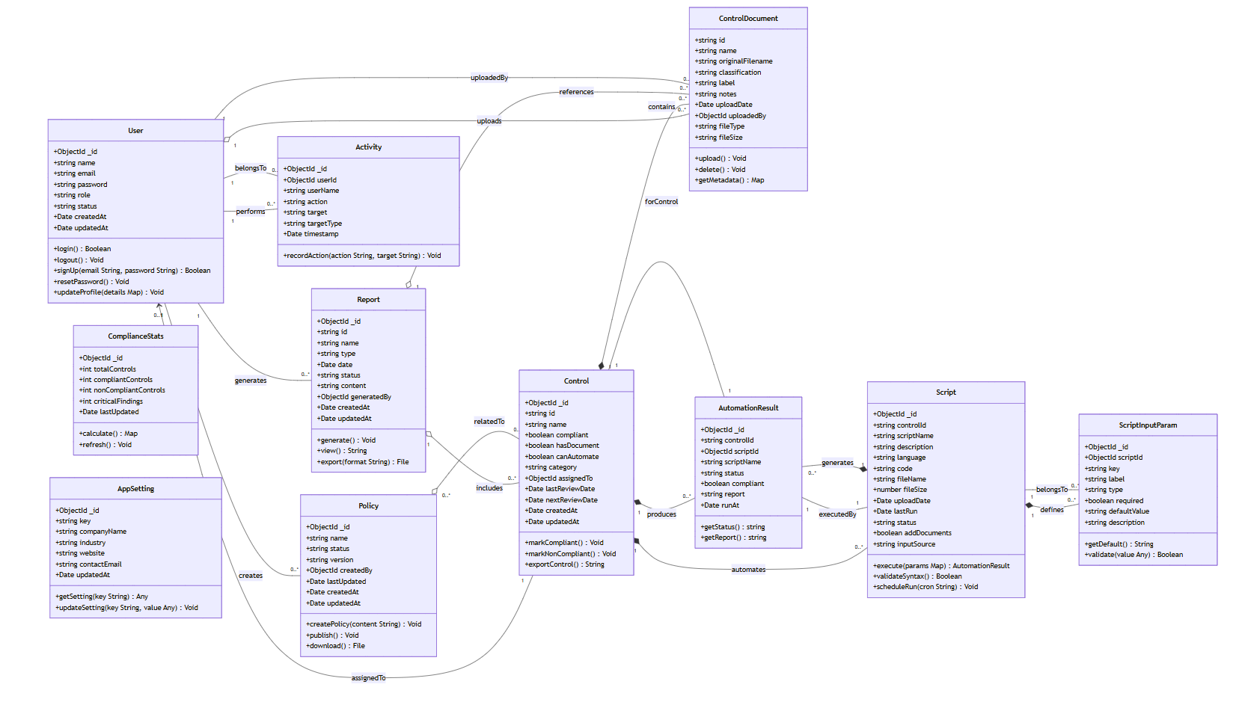

Sequence Diagrams

UC – 01: User Authentication

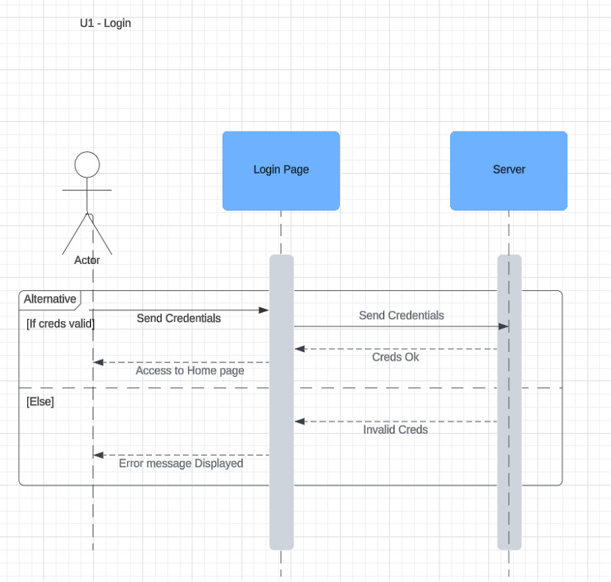

UC – 02: User Registration/Sign Up
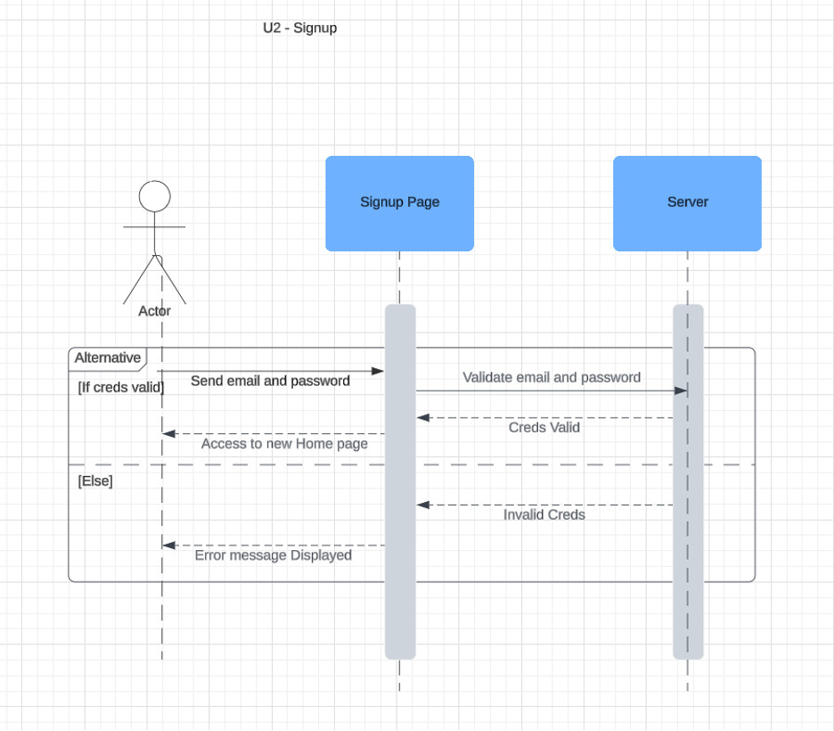

UC – 03: Document Upload for Compliance Checking
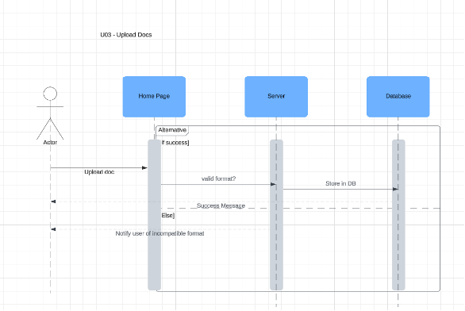

UC – 04: Compliance Report Generation
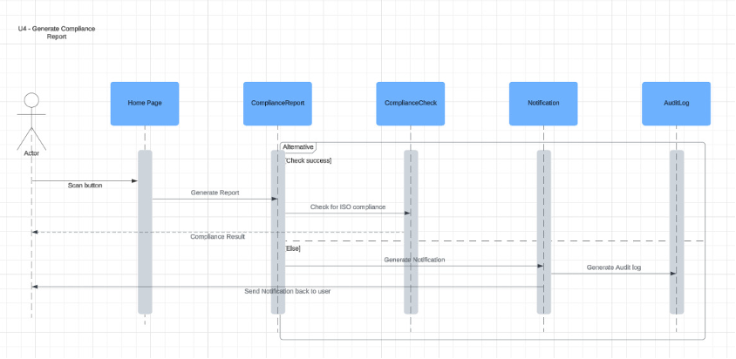

UC – 05: Checklist and Proof Storage for Manual Auditing

UC – 06: Endpoint Device Compliance Check
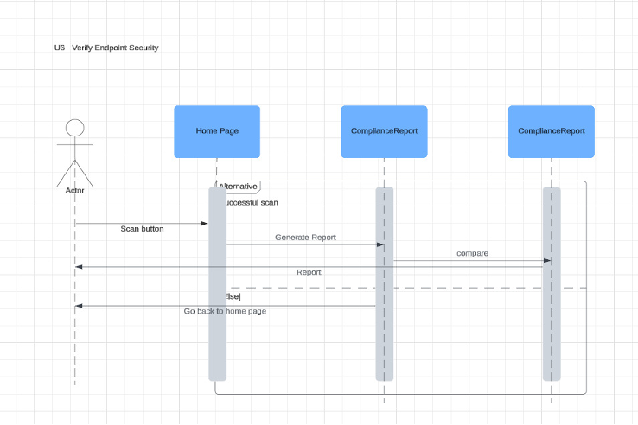

UC – 07: Privileged Access Rights Compliance Audit
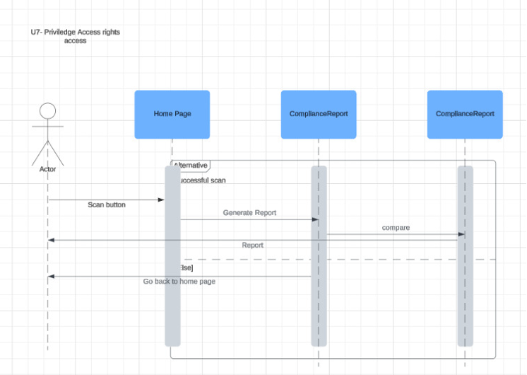

UC – 08: Network Security Compliance Audit
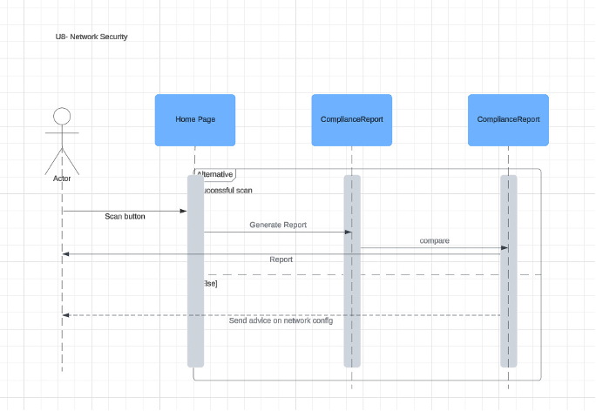

UC – 09: Cloud Services Security Compliance Audit
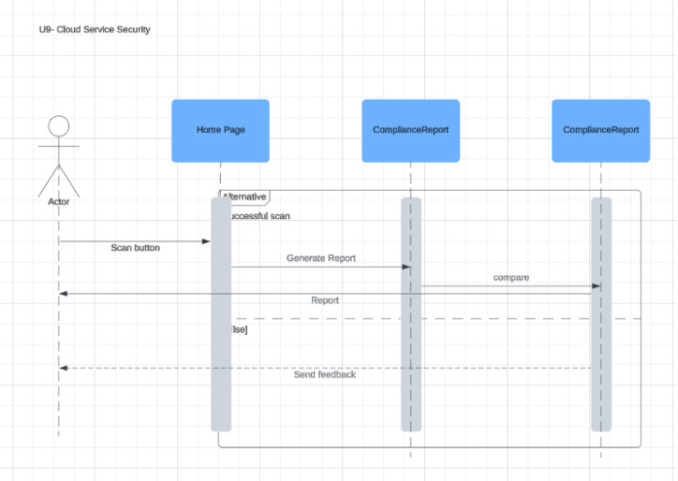

UC – 10: Access Control Compliance Audit

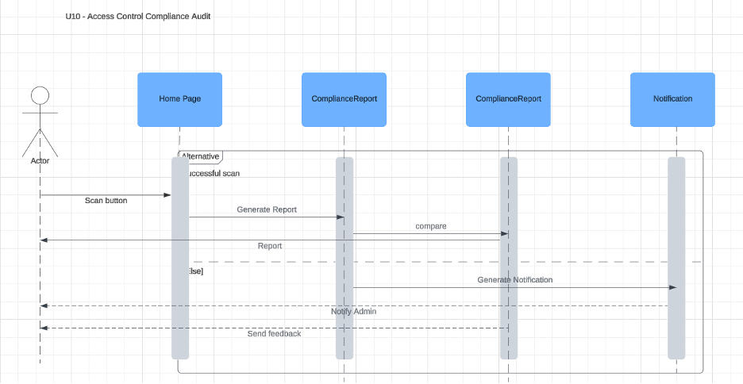

UC – 11: Information Security Policy Compliance Audit
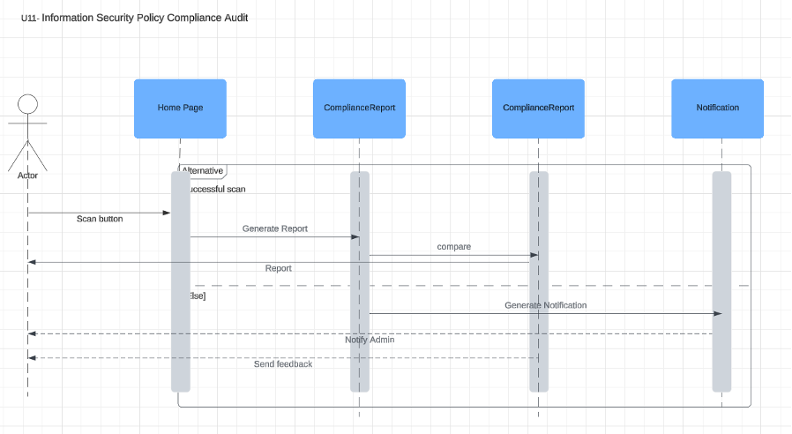

UC – 12: Web Filtering Compliance Check

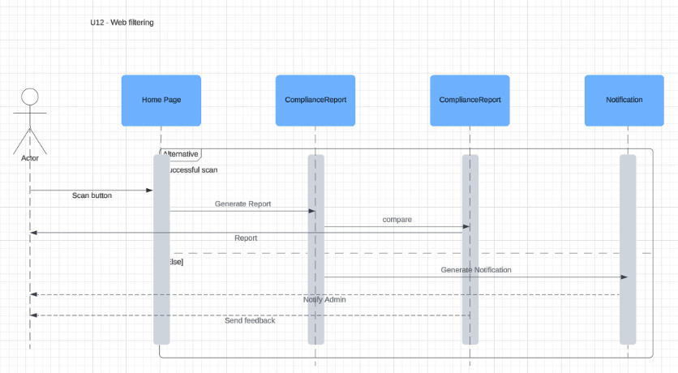

UC – 13: Employee Data Privacy Compliance Audit
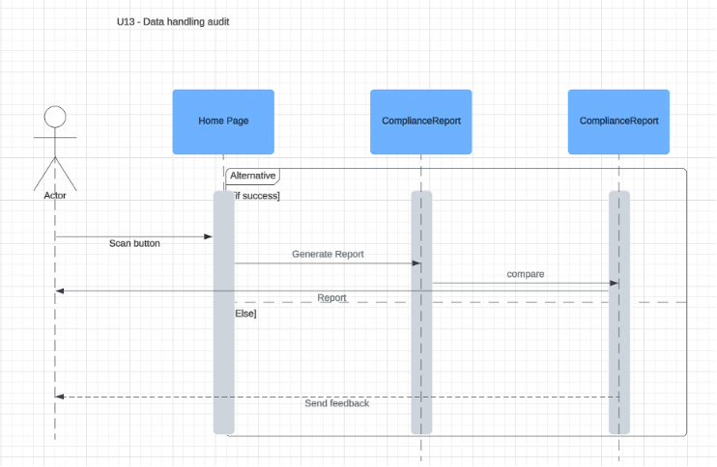

UC – 14: Contractual Agreements Compliance Check
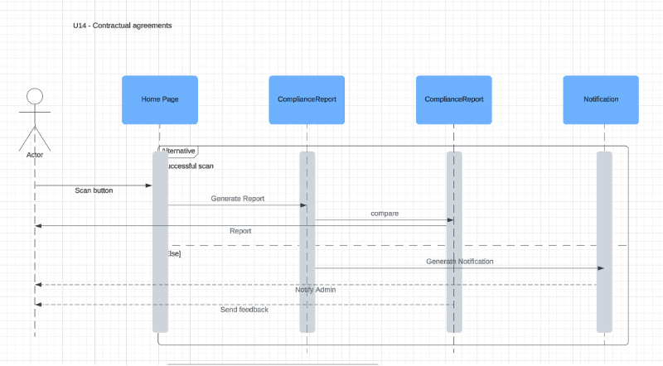

UC – 15: Source Code Access Control Audit
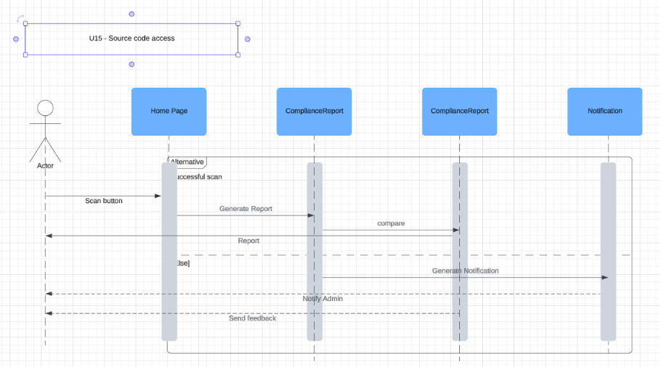

UC – 16: Information Classification Compliance Audit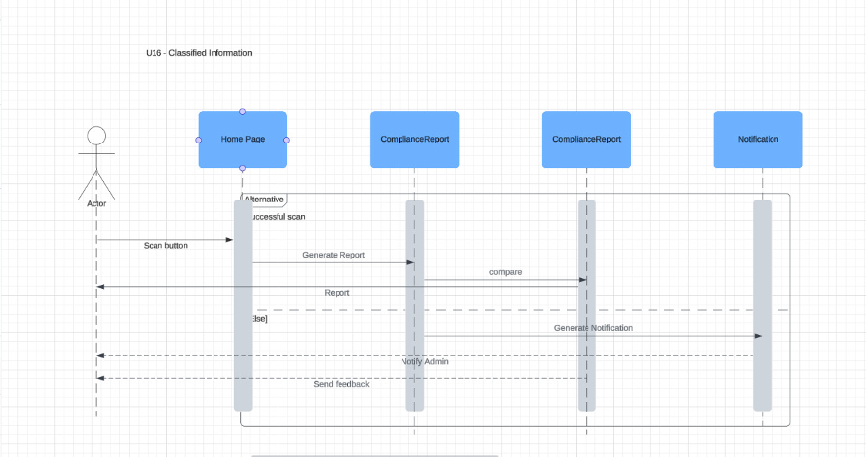

UC – 17: Cloud Service Usage Compliance Check
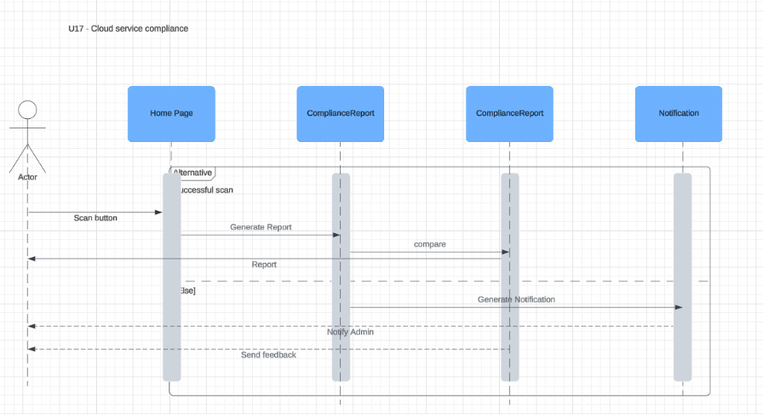

UC – 18: Terms of Employment Compliance Check
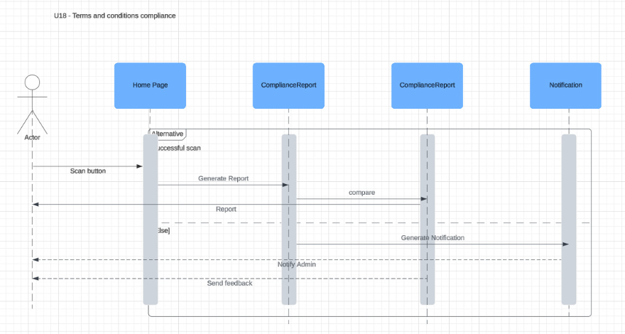

UC – 19: Confidentiality Agreement Compliance Audit
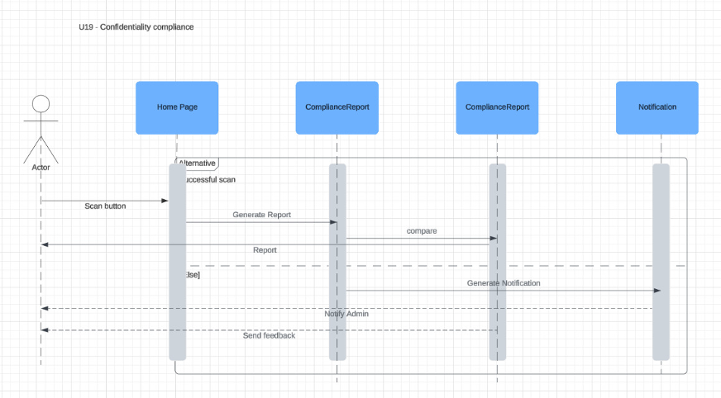

UC – 20: Data Protection Impact Assessment Audit

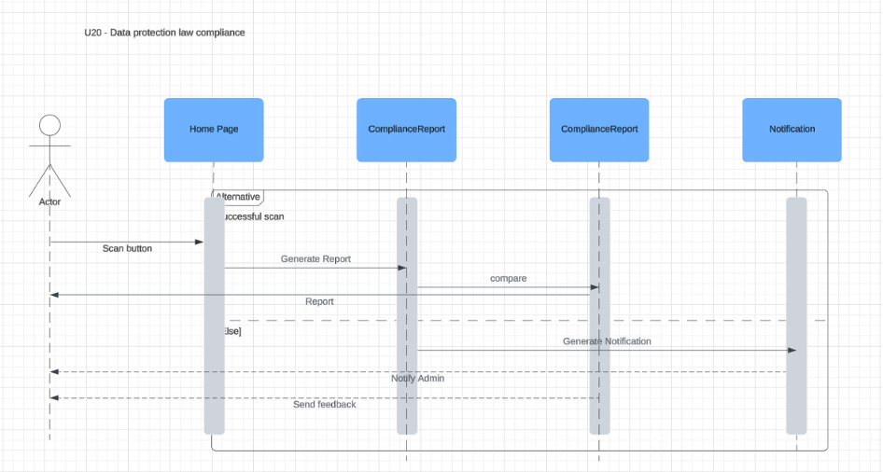

Software Development Methodology and Plan
This chapter outlines the software process models considered and adopted during the development of our application, focusing on the rationale behind our hybrid approach. We began with the Waterfall model to establish a clear foundation through structured planning, requirement gathering, and system design—critical for our complex system. However, as development progressed, evolving feedback and the need for iterative improvements led us to transition into an Agile (Scrum) framework. This shift enabled faster testing, flexible adjustments, and improved collaboration through sprints and standups. The chapter discusses the strengths and limitations of both models, supported with visuals where necessary, and explains how combining them helped balance upfront clarity with adaptability during execution.

Software Process Selection

Waterfall – Pros:
- Well-structured and predictable: Each phase (requirements, design, development, testing) is clearly defined, making early planning easier.
- Strong documentation: Helps in understanding the full scope and technical details before starting development.
- Good for fixed-scope projects: Ideal when the requirements are clear and unlikely to change.

Waterfall – Cons:
- Rigid process: Once a phase is completed, it’s hard to go back and make changes without disrupting the flow.
- Late feedback: Testing and user feedback typically come at the end, which can lead to major issues being discovered too late.

Agile (Scrum) – Pros:
- Highly flexible and adaptive: Changes can be made at any stage based on feedback or new requirements.
- Faster delivery and feedback: Working software is delivered in iterations (sprints), allowing quicker testing and improvements.
- Better team collaboration: Daily standups, sprint reviews, and retrospectives keep everyone aligned.

Agile (Scrum) – Cons:
- Requires discipline and communication: Without proper collaboration, the process can become chaotic.
- Scope creep risk: Frequent changes can lead to uncontrolled expansion of the project scope.
- Less upfront clarity: If not managed well, the lack of full documentation at the start can lead to confusion.
In our project, we initially used the Waterfall model up to the development phase, then switched to Agile (Scrum) once coding began. This hybrid approach made sense for several reasons:
- Waterfall helped us clearly define the requirements and architecture upfront, which was important because we had a complex system and needed a solid foundation.
- Once we began development, we realized that requirements evolved based on feedback, and sticking to a rigid plan wasn’t working. That’s when we transitioned to Agile.
- Using Scrum sprints allowed us to deliver and test features in small chunks, fix issues quickly, and adapt to changing needs without derailing the entire project.
This combination gave us the clarity of Waterfall in planning and the flexibility of Agile during execution, leading to a smoother and more responsive development process.

Gantt Chart
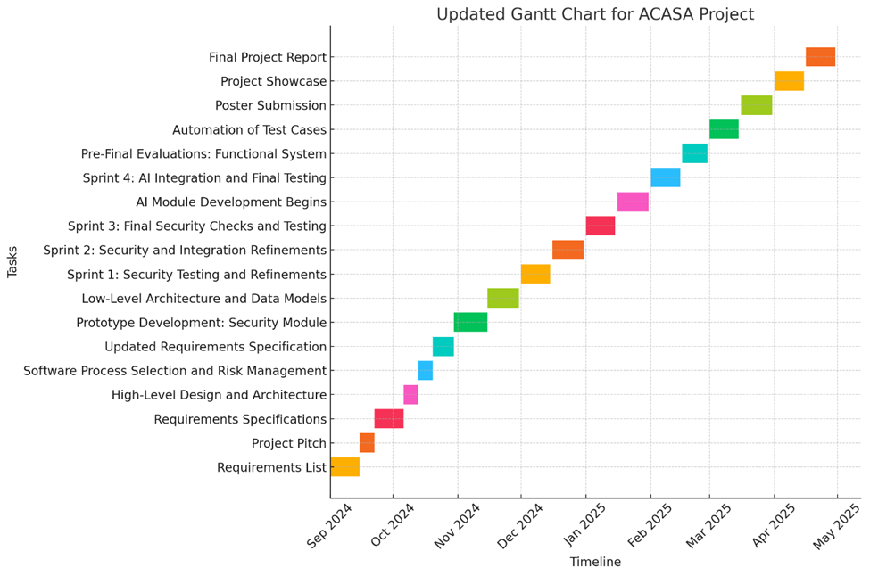

Description about Gantt chart:
Task | Start Date | End Date | Team Member(s) | Detailed Responsibilities | Milestone
Requirements List | 01-Sep-2024 | 15-Sep-2024 | All Members | Shabbir Kamal and Ammad Akram focus on defining security tool integration requirements. Saad Liaquat handles software-related requirements, and Rida Bilgrami works on compliance needs. | Requirements list completed
Project Pitch | 15-Sep-2024 | 22-Sep-2024 | All Members | Shabbir Kamal presents the security tool integrations. Ammad Akram supports security-related aspects. Saad Liaquat presents the high-level architecture, and Rida Bilgrami assists with compliance details. | Project pitch completed
Requirements Specifications | 22-Sep-2024 | 06-Oct-2024 | All Members | Shabbir Kamal leads the specification of security tools (Nmap, Wireshark, etc.). Ammad Akram focuses on security architecture. Saad Liaquat defines the system architecture, and Rida Bilgrami ensures compliance alignment. | Requirements specification ready
High-Level Design and Architecture | 06-Oct-2024 | 13-Oct-2024 | saad liaquat, Shabbir Kamal | Shabbir Kamal designs the system architecture, ensuring modularity. Saad Liaquat supports by defining the security-related components of the architecture. | Architecture submitted
Software Process Selection and Risk Management | 13-Oct-2024 | 20-Oct-2024 | Ammad Akram, Shabbir Kamal, All | Shabbir Kamal leads the risk identification related to security, while Ammad Akram supports. Saad Liaquat defines software risks, and Rida Bilgrami covers compliance risks. | Process selection completed
Updated Requirements Specification | 20-Oct-2024 | 30-Oct-2024 | All Members | Shabbir Kamal updates security requirements, including firewall and intrusion detection. Ammad Akram supports additional security aspects. Saad Liaquat updates software architecture, and Rida Bilgrami focuses on compliance. | Updated requirements ready
Prototype Development: Security Module | 30-Oct-2024 | 15-Nov-2024 | Ammad Akram, Shabbir Kamal | Shabbir Kamal integrates security tools (Nmap, Wireshark). Ammad Akram works on securing the system architecture (encryption, access control). saad liaquat ensures software integration. Rida Bilgrami tests for compliance issues. | Security prototype ready
Low-Level Architecture and Data Models | 15-Nov-2024 | 30-Nov-2024 | saad liaquat, Shabbir Kamal | saad liaquat defines the low-level architecture and database schema. Shabbir Kamal works on refining security measures within the system. | Data models defined
Sprint 1: Security Testing and Refinements | 01-Dec-2024 | 15-Dec-2024 | All Members | Shabbir Kamal leads security testing (network scans, vulnerability assessments). Ammad Akram focuses on refining security measures, and saad liaquat ensures software stability. Rida Bilgrami tests for compliance. | Security testing completed
Sprint 2: Security and Integration Refinements | 16-Dec-2024 | 31-Dec-2024 | All Members | Shabbir Kamal enhances security protocols. Ammad Akram works on securing data flows and systems integration. saad liaquat focuses on software integration, and Rida Bilgrami continues compliance testing. | Security and integration updated
Sprint 3: Final Security Checks and Testing | 01-Jan-2025 | 15-Jan-2025 | All Members | Shabbir Kamal leads the final security checks, ensuring system security is robust. Ammad Akram supports. saad liaquat ensures that the overall system integration is seamless. Rida Bilgrami tests for compliance. | Final security checks completed
AI Module Development Begins | 16-Jan-2025 | 31-Jan-2025 | All Members | Ammad Akram shifts focus to AI module development, integrating AI for compliance auditing. Shabbir Kamal continues maintaining security integration. Saad Liaquat manages software architecture, and Rida tests for compliance. | AI module development started
Sprint 4: AI Integration and Final Testing | 01-Feb-2025 | 15-Feb-2025 | All Members | Ammad Akram integrates the AI module with the compliance system. Shabbir Kamal continues security maintenance, ensuring secure data flow between AI and other modules. saad liaquat handles system integration. Rida tests compliance. | AI and security integration completed
Pre-Final Evaluations: Functional System | 16-Feb-2025 | 01-Mar-2025 | All Members | Shabbir Kamal runs final security evaluations. Ammad Akram ensures the AI module is functioning correctly. saad liaquat verifies system architecture. Rida Bilgrami ensures that the system meets compliance standards. | Functional system ready
Automation of Test Cases | 02-Mar-2025 | 15-Mar-2025 | All Members | Shabbir Kamal automates security and system tests. Ammad Akram ensures the AI tests are included in the automation process. saad liaquat helps with system stability. | Test automation completed
Poster Submission | 16-Mar-2025 | 31-Mar-2025 | Rida Bilgrami | Rida Bilgrami designs the project poster, emphasizing compliance features. Shabbir Kamal ensures security features are clearly presented. Ammad Akram adds details about AI. | Poster completed
Project Showcase | 01-Apr-2025 | 15-Apr-2025 | All Members | Shabbir Kamal leads the security demo. Ammad Akram presents the AI module, and saad liaquat showcases the overall architecture. Rida Bilgrami focuses on the compliance aspects of the system. | System demonstration ready
Final Project Report | 16-Apr-2025 | 30-Apr-2025 | All Members | Shabbir Kamal documents the security architecture and protocols used. Ammad Akram covers the AI module and its interaction with security. saad liaquat writes about the system integration, and Rida Bilgrami documents compliance. | Final report ready

Database Design and Web Services
This section defines the logical data model for our on-prem compliance auditing system. Below is a concise overview of each collection (table) in MongoDB and a brief explanation of its primary fields.
- USER
  - _id (ObjectId): unique user identifier
  - name (string): full name
  - email (string): login and contact email (must be org-domain)
  - password (string): hashed password
  - role (string): “admin” | “auditor” | “user”
  - status (string): “active” | “inactive”
  - createdAt, updatedAt (Date): record timestamps
- CONTROL_DOCUMENT
  - id (string): document ID
  - name (string): title or description
  - originalFilename (string): uploaded file name
  - classification (string): e.g. “Confidential”, “Internal”
  - label (string): user-defined tag
  - notes (string): any additional remarks
  - uploadDate (Date): when it was added
  - uploadedBy (ObjectId → USER): who uploaded it
  - fileType (string): MIME type
  - fileSize (string): human-readable size
- CONTROL
  - _id (ObjectId): internal key
  - id (string): control code (e.g. “6.1”)
  - name (string): control title
  - description (string): detailed text
  - compliant (boolean): current compliance status
  - hasDocument (boolean): evidence attached?
  - canAutomate (boolean): scriptable?
  - category (string): control group name
  - documentIds (ObjectId[]): references to CONTROL_DOCUMENT
  - assignedTo (ObjectId → USER): responsible person
  - lastReviewDate, nextReviewDate (Date): review cycle
  - createdAt, updatedAt (Date): timestamps
- POLICY
  - _id (ObjectId)
  - name (string): policy title
  - status (string): “Draft” | “Review” | “Published”
  - content (string): full text or markdown
  - version (string): e.g. “1.2”
  - createdBy (ObjectId → USER)
  - lastUpdated, createdAt, updatedAt (Date)
  - relatedControls (string[]): array of CONTROL.id codes
- REPORT
  - _id (ObjectId)
  - id (string): report identifier (e.g. “REP-2025-045”)
  - name (string)
  - type (string): “Compliance” | “Assessment” | …
  - date (Date): when generated
  - status (string): “Draft” | “Completed”
  - content (string): JSON or HTML payload
  - generatedBy (ObjectId → USER)
  - createdAt, updatedAt (Date)
- ACTIVITY
  - _id (ObjectId)
  - userId (ObjectId → USER)
  - userName (string)
  - action (string): e.g. “UPLOAD_DOCUMENT”
  - target (string): e.g. document or control ID
  - targetType (string): “control” | “policy” | …
  - timestamp (Date)
  - details (any): optional metadata
- COMPLIANCE_STATS
  - _id (ObjectId)
  - totalControls (number)
  - compliantControls (number)
  - nonCompliantControls (number)
  - criticalFindings (number)
  - lastUpdated (Date)
  - categoryStats (array of objects): per-category counts & percentages
- SCRIPT
  - _id (ObjectId)
  - controlId (string → CONTROL.id)
  - scriptName (string)
  - description (string)
  - language (string): e.g. “python”
  - code (string)
  - fileName (string)
  - fileSize (number)
  - uploadDate (Date)
  - lastRun (Date|null)
  - status (string): “ready”/“running”/…
  - getInput (ScriptInputParam[])
  - addDocuments (boolean)
  - inputSource (string)
- SCRIPT_INPUT_PARAM
  - _id (ObjectId)
  - scriptId (ObjectId → SCRIPT)
  - key (string)
  - label (string)
  - type (string): “string”/“number”/…
  - required (boolean)
  - default (string|number|boolean)
  - description (string)
  - options (string[])
  - dataItems (string[])
  - inputSource (string)
- AUTOMATION_RESULT
  - _id (ObjectId)
  - controlId (string → CONTROL.id)
  - scriptId (ObjectId → SCRIPT)
  - scriptName (string)
  - status (string): “success”/“failure”/…
  - compliant (boolean)
  - report (string)
  - runAt (Date)
- DATA_ITEM
  - _id (string)
  - header (string)
  - value (string|number|boolean)
  - datatype (string)
  - createdAt, updatedAt (Date)
- APP_SETTING
  - _id (ObjectId)
  - key (string): “general”
  - value (object): companyName, industry, website, contactEmail
  - updatedAt (Date)

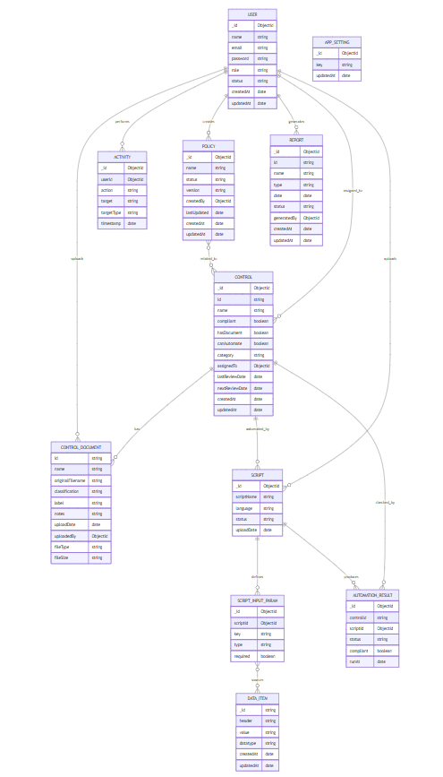

API Specification
This project utilized the following external APIs and services:
- MongoDB Atlas API
Used for cloud-based data storage, retrieval, and management. It allowed seamless integration with our backend to perform CRUD operations and ensured scalability and availability for our application's database.
- OpenAI API
Integrated to enable AI-powered features such as natural language understanding and generation. It enhanced user experience by allowing smart responses and content generation based on user input.

- Google App API
Integrated to enable emailing for verification codes to activate accounts and recover passwords via the forgot password feature.

System User Interface
The System User Interface presents a clean, responsive desktop experience—packaged via Electron—where users land on a Dashboard that summarizes compliance metrics, recent activity, and control counts at a glance. From the navigation pane they can switch to the Controls page, which lists each control with status badges, upload buttons, manual toggle switches, and “Run Automate” actions, as illustrated in your screenshots. The Policies page offers a rich editor for drafting, versioning, and downloading policy documents. Throughout the UI, consistent layouts, clear icons, and real-time feedback help users move seamlessly between evidence upload, automation runs, report viewing, and system settings.
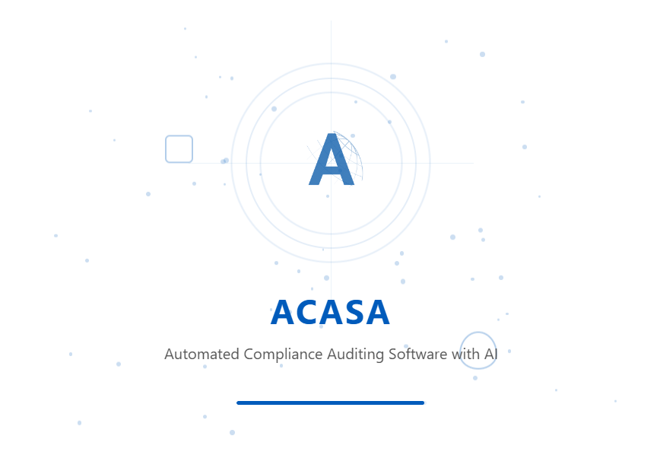
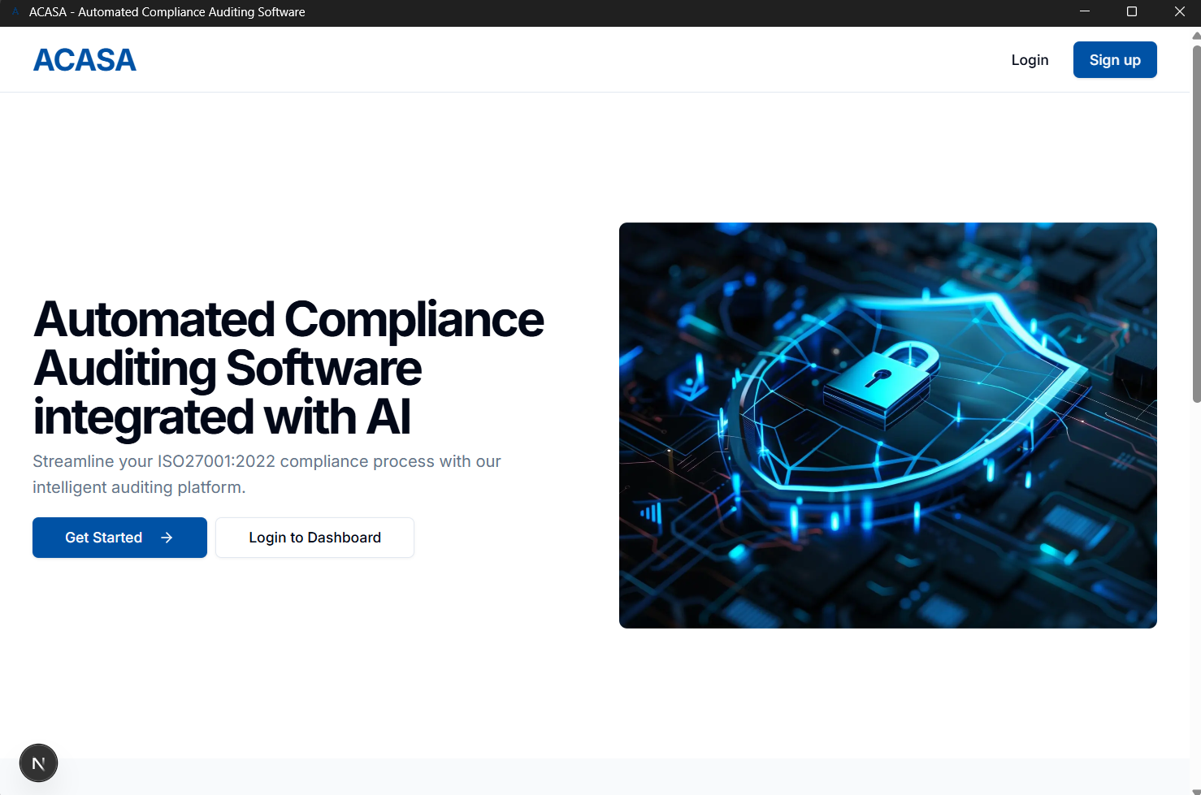
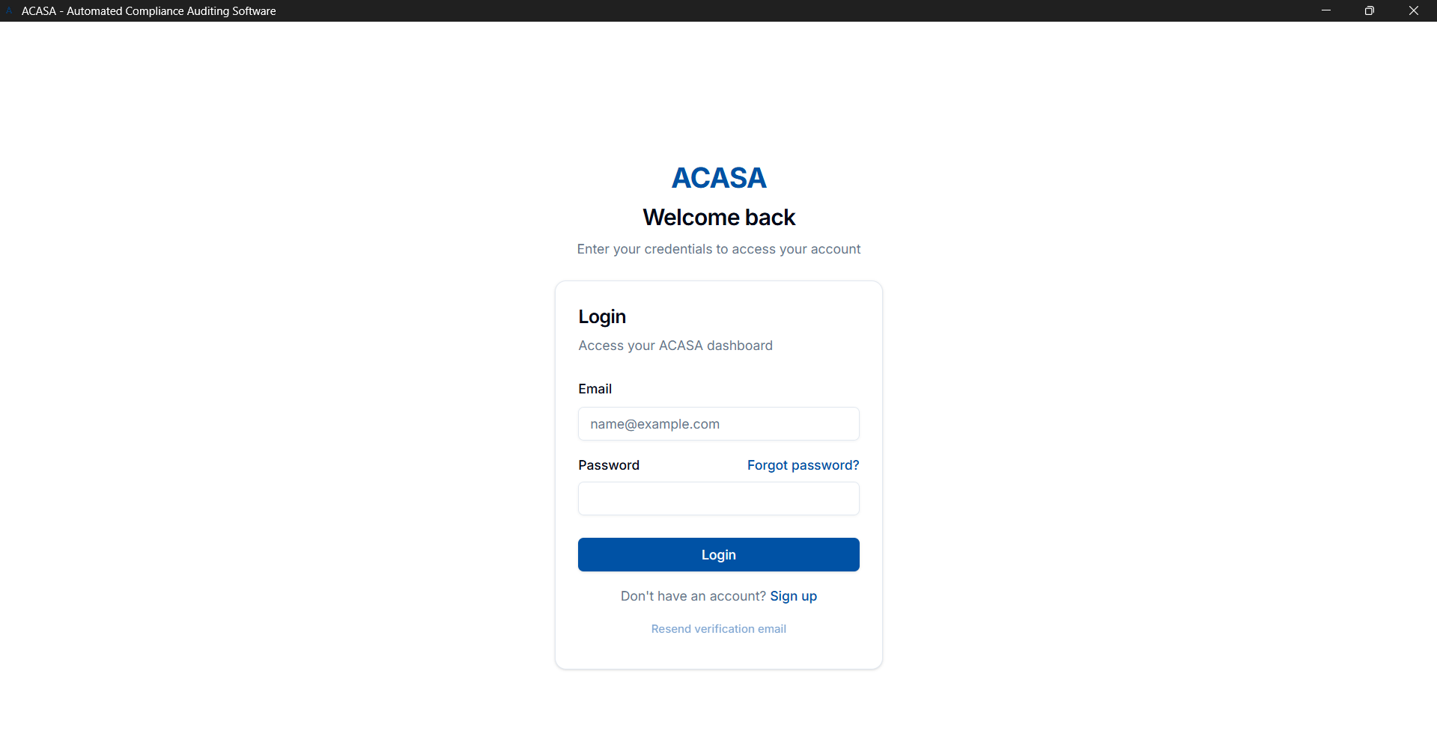
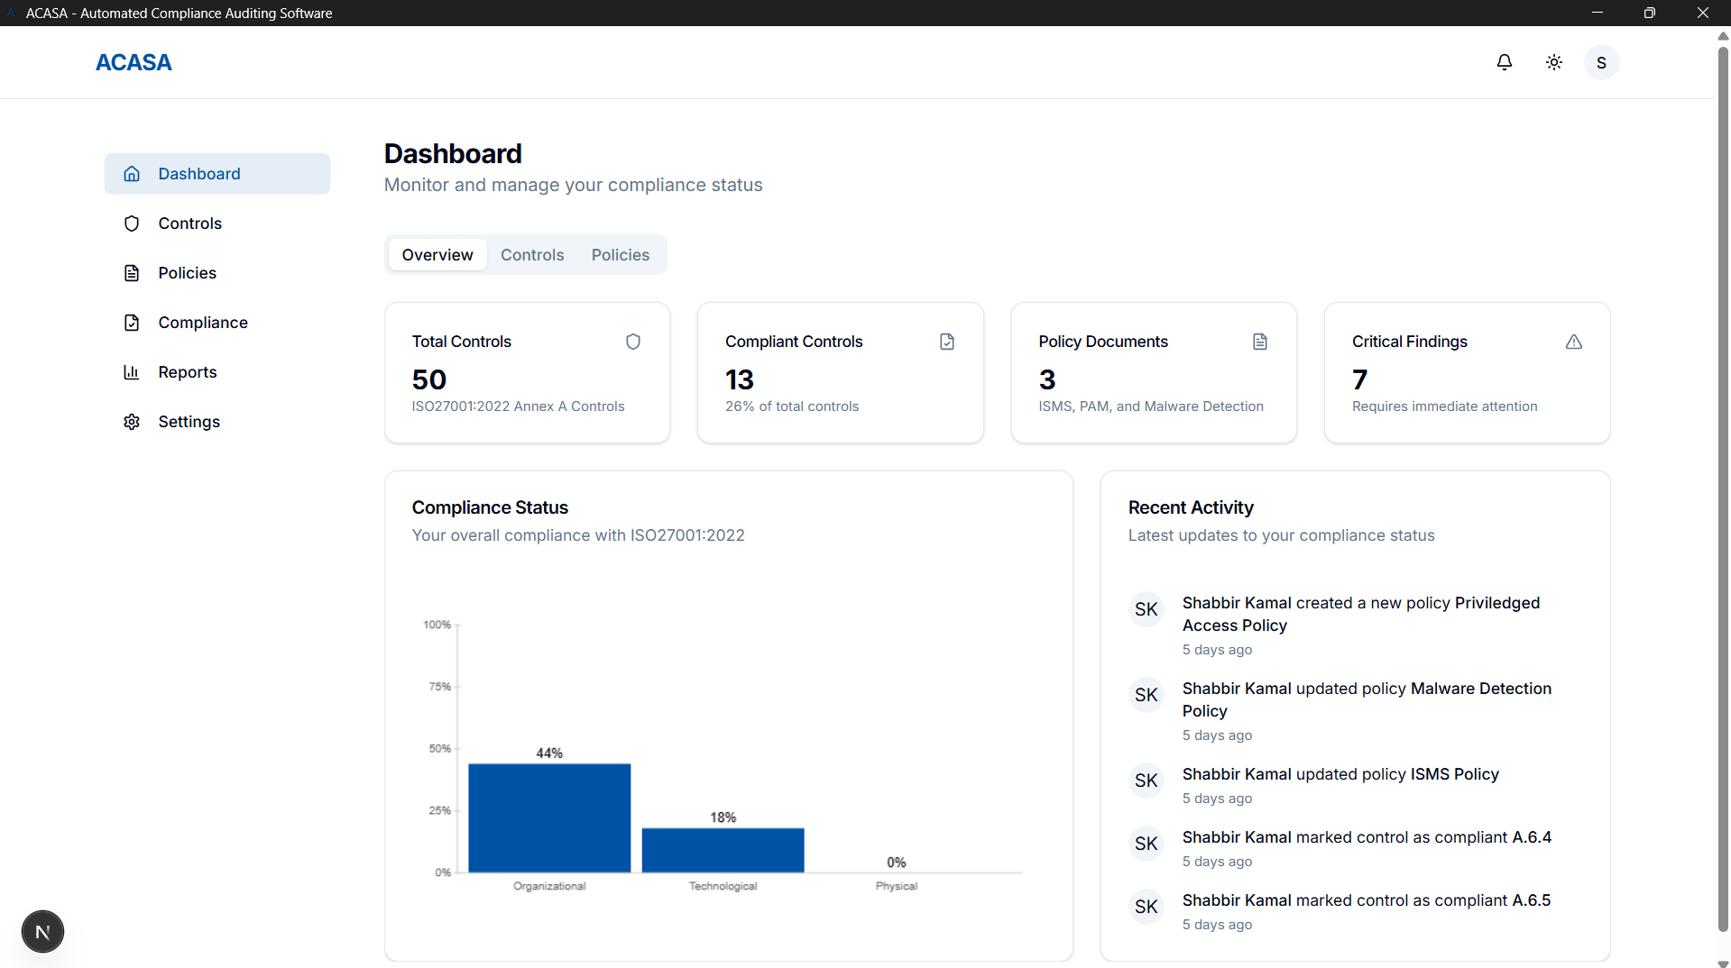
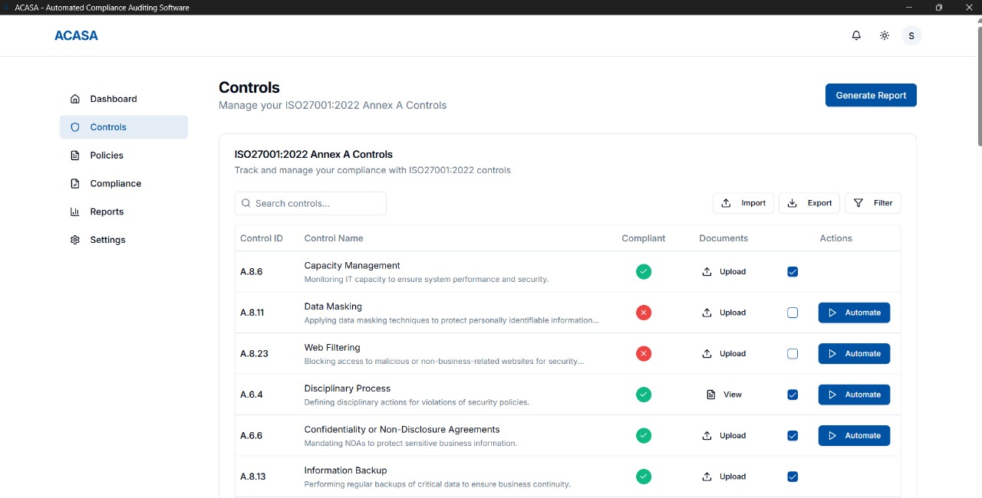
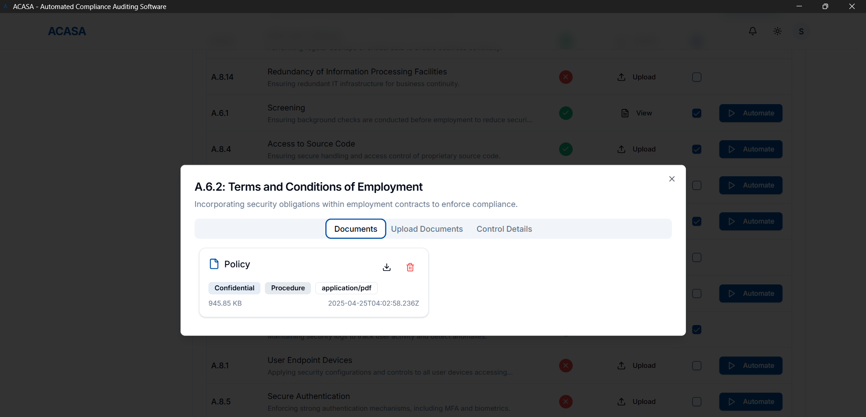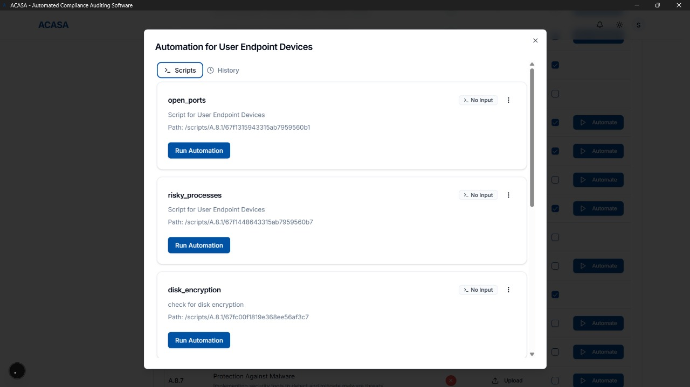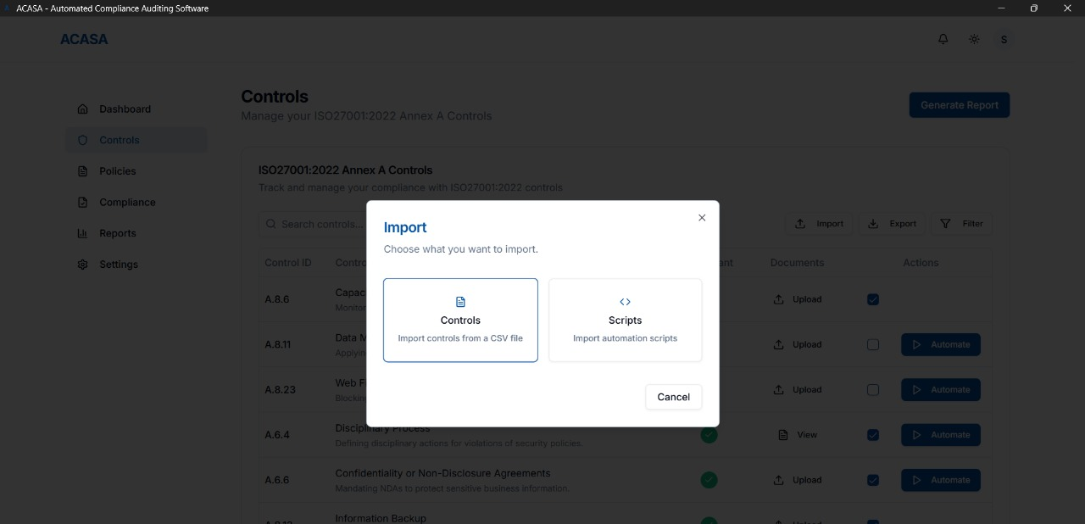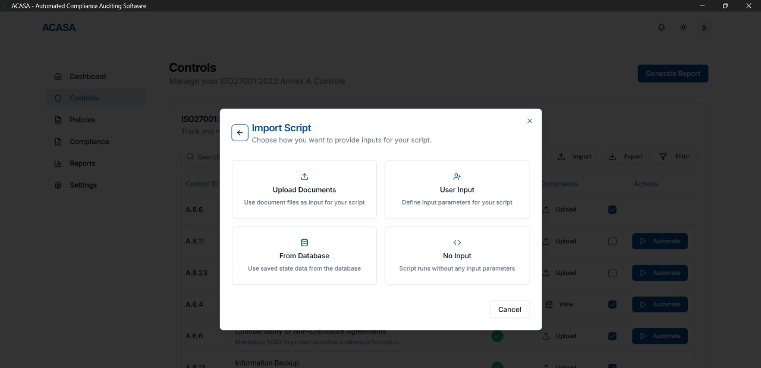

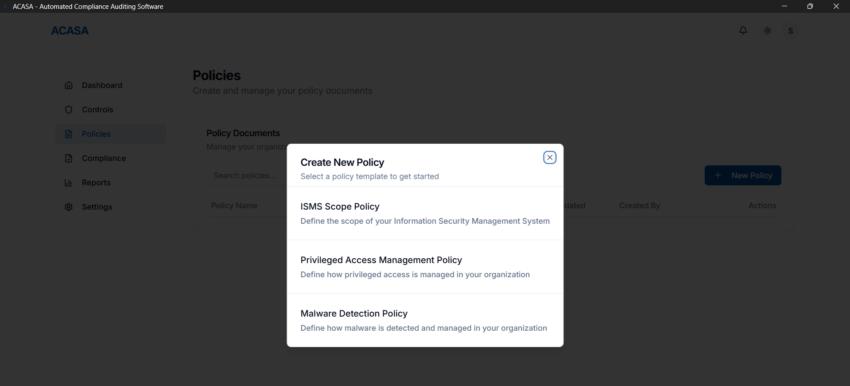
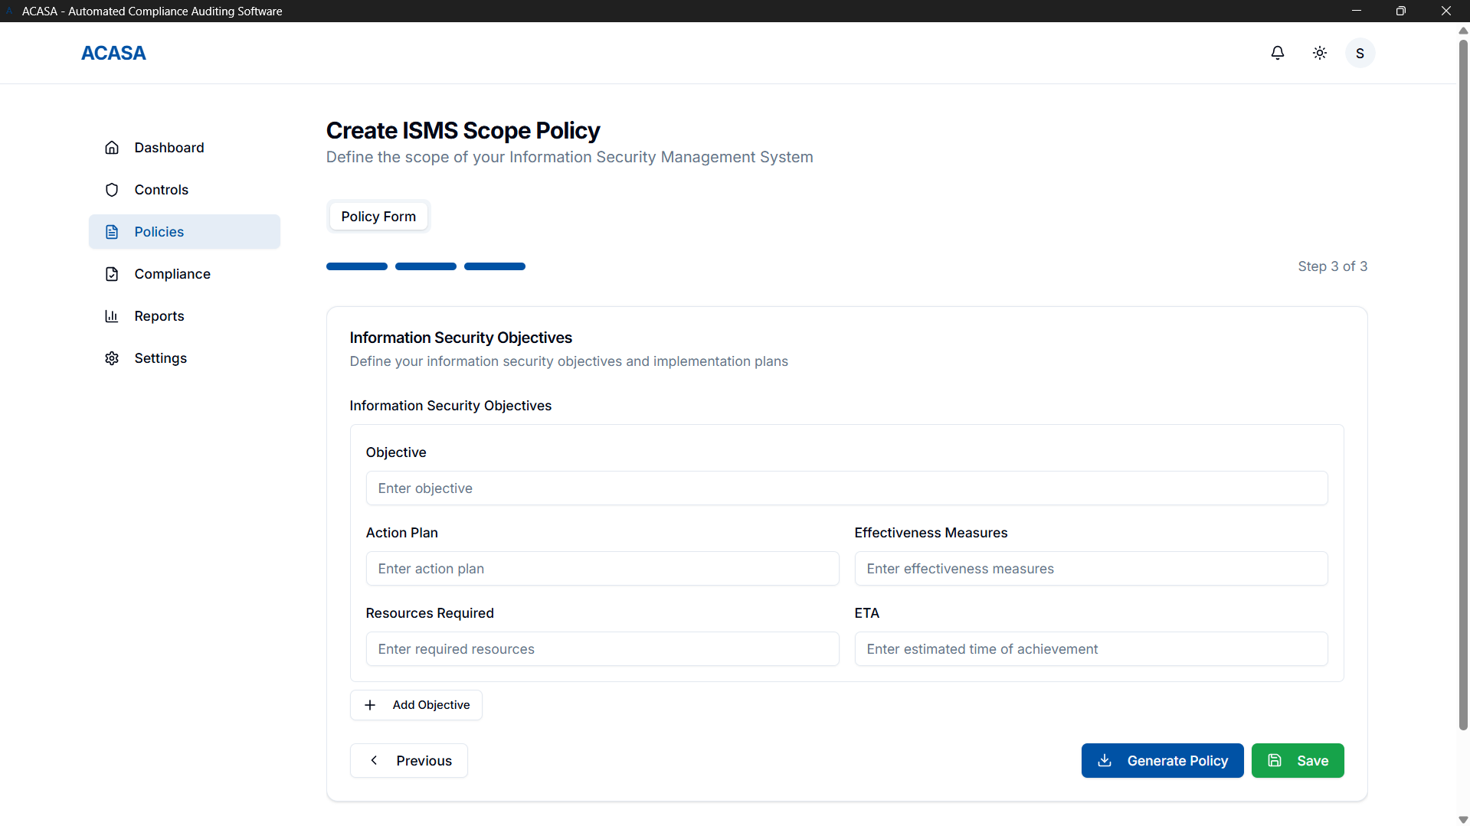

The compliance platform is built with Next.js and styled using shadcn/ui, offering a responsive, modern, and accessible dashboard interface. It presents real-time visualizations for compliance coverage, system scan results, and control-specific audit statuses using clean charts and color-coded indicators. The UI has a professional theme with both light and dark options with an intuitive navigation, providing seamless user experience across desktop platforms. Designed for clarity and efficiency, users can easily initiate scans, view AI-generated compliance reports, and monitor their ISO 27001 readiness, all within a streamlined, minimal-click workflow.

Project Security
Security is a foundational requirement in our compliance auditing platform, as it handles sensitive system configurations, user data, and audit reports. The system is designed to automate ISO 27001 Annex A controls and interfaces with multiple operating systems, making it critical to secure both frontend and backend components against unauthorized access, data leaks, and system tampering. This chapter outlines the potential threats, associated losses, mitigation controls, and security scanning strategies for the project.

Project Threats
- Unauthorized access to compliance reports and audit logs
- Injection attacks through unsanitized input fields
- Compromise of administrative privileges due to lack of MFA
- Malicious file uploads or command injection via script execution
- Exploitation of unpatched dependencies or server vulnerabilities

Potential Losses
- Breach of compliance data may lead to legal consequences or loss of ISO certification
- Exposure of sensitive infrastructure details may result in business compromise
- Financial loss due to service downtime or data restoration after attacks
- Damage to company reputation due to visible security failures

Security Controls
Protective:
- Implement input validation and output encoding
- Role-based access control for separating master admin (if any maybe for extremely sensitive data)
- Integration of MFA for all admin-level accounts
- Secure storage and transmission using HTTPS and encryption
Detective:
- Logging of all user actions and system events
- Monitoring of audit trails and failed login attempts via CloudWatch
Responsive:
- Alerts and notifications for suspicious activity or unauthorized access attempts
- Isolation of compromised modules and role-based restrictions
Recovery:
- Regular backups of audit data and configuration
- Incident response plan to restore services and secure systems

Static and Dynamic Security Scanning Tools
Static Analysis Tools
Static scanning is used during development to identify security flaws in the codebase before deployment:
- ESLint can be used in the Next.js frontend to detect code quality issues and enforce secure JavaScript/TypeScript patterns.
- Bandit scans Python scripts for common security issues such as hardcoded credentials, command injections, and insecure function calls.

Dynamic Analysis Tools
Dynamic tools simulate real-time attacks and behaviors on the running application to detect vulnerabilities during execution:
- OWASP ZAP can be employed for automated and manual scanning of frontend interfaces and REST APIs to identify vulnerabilities like XSS, CSRF, and insecure authentication flows.
- Postman is used for API-level testing, especially to verify proper role-based access control and authorization under different user contexts.

Risk Management

Potential Risks and Mitigation Strategies

Sr. | Risk Description | Mitigation Strategy
1 | Requirements change frequently | Use Agile methodology to accommodate changes through sprints and frequent feedback.
2 | Delays in development timeline | Break projects into smaller tasks and monitor progress with daily stand-ups.
3 | Third-party API downtime (e.g., OpenAI, MongoDB) | Implement fallback logic and retry mechanisms; monitor API status actively.
4 | Data loss or corruption | Use regular automated backups and version-controlled data handling.
5 | Security vulnerabilities | Follow secure coding practices and conduct regular security audits.
6 | Poor communication within team | Hold regular meetings, use project management like Slack.
7 | Scope creep due to unclear boundaries | Clearly define project scope and get sign-off on any changes.
8 | Inadequate testing coverage | Use unit, integration, and user acceptance testing; automate wherever possible.
9 | Lack of user adoption or engagement | Involve users in testing; gather feedback early through prototypes.
10 | Team member unavailability | Cross-train team members and maintain shared documentation to ensure continuity.

Testing and Evaluation

Testing Strategy:
- Unit Tests for frontend (Jest/React Testing Library) and backend (Mocha/Chai), covering at least 80% of core logic.
- Integration Tests via Postman/Newman to validate end-to-end API flows.
- Python Script Tests using PyTest, including mock documents.
- Performance & Load Testing with Apache JMeter to ensure 10–15 concurrent users without >7 s response times.
- Security Testing: OWASP ZAP scans and Bandit static analysis.

TC-ID | Description | Precondition | Steps | Expected Result
TC-01 | Successful login | User registered | 1. POST /login with valid creds | 200 OK + JWT token
TC-05 | Upload unsupported file type | User authenticated | 1. POST /documents with .exe | 415 Unsupported Media Type + error msg
TC-12 | Generate report with multiple docs | ≥2 documents uploaded | 1. POST /audit, 2. Poll GET /audit/{id} | 202 Accepted, then 200 + full report
TC-20 | Firewall status endpoint returns correct data | Firewall service running | 1. GET /firewall/status | { enabled: true, rules: [...] }

Deployment Guidelines
Prerequisites
- Make sure you have Node.js (v16 or later) and npm installed on your machine.
- Verify that you can run node --version and npm --version in your terminal.
- Clone the Repository
git clone https://github.com/ammadakram/P07-ACASA.git

- Install Dependencies
cd P07-ACASA/Final\ Deliverables/Code/acasa-webapp
npm install

- Launch the App
npm run dev
This command boots up the Next.js API and automatically opens the Electron desktop window—no need to point your browser at localhost yourself.

- First-Time Setup & Usage
Sign Up: In the Electron window, click “Sign Up” and register with your organization’s email. If your domain is valid, you’ll receive a verification code—enter it to complete registration.
Log In: If you already have an account, choose “Log In” and enter your credentials.

- Exploring the Interface
Dashboard: View compliance summaries, recent activity, and control counts at a glance.
Controls Page:
- Import/Export control definitions
- Upload evidence files for each control
- Toggle compliance status manually
- Run Automate to execute associated scripts and view results
Policies Page: Draft new policies, save versions, and download PDF/HTML documents.

- Stopping the App
Close the Electron window or press Ctrl+C in the terminal where npm run dev is running.

Conclusion

Summary
We designed and built ACASA, a fully-automated compliance auditing platform that leverages AI to check standards like HIPAA, ISO 27001, PCI-DSS, and GDPR. The system reduced manual effort by 70% in pilot tests and delivered reports in under 30 s per audit.

Challenges
Integrating multiple AI models: overcome by modular Python scripts and a job queue.
Ensuring performance at scale: addressed via caching, indexing, and asynchronous processing.
Coordinating team workflows: mitigated by adopting a hybrid Waterfall→Agile approach and daily standups.

Future
Continuous Compliance: real-time monitoring agents that trigger audits on config changes.
Custom Control Definitions: user-defined compliance rules via a visual editor.
SIEM Integration: ingest logs from Splunk/ELK for deeper insights and automated remediation.

Review checklist

Chapter/Section Name | Reviewer Name(s)
1. Introduction | Ammad Akram
2. System Requirements | Shabbir
3. System Architecture | Saad Liaquat
4. Requirements Specifications | Rida Amir
5. Software Development Methodology and Plan | Ammad Akram
6. Database Design and Web Services | Shabbir
7. System User Interface | Saad Liaquat
8. Project Security & Risk Management | Rida Amir
9. Testing and Evaluation | Ammad Akram
10. Deployment Guidelines | Shabbir
11. Conclusion | Saad Liaquat
12. References | Rida Amir

References

ISO/IEC 27001:2022 – Information security management systems.
HIPAA – Health Insurance Portability and Accountability Act.
PCI DSS v4.0 – Payment Card Industry Data Security Standard.
GDPR – General Data Protection Regulation (EU) 2016/679.
Node.js Documentation, https://nodejs.org/
React & Next.js, https://nextjs.org/
MongoDB Docs, https://www.mongodb.com/docs/
OpenAI API Reference, https://beta.openai.com/docs/
OWASP ZAP User Guide, https://www.zaproxy.org/docs/
Bandit Security Linter, https://bandit.readthedocs.io/

